

***Amrita Vidyalayam***

***Ettimadai***

***BANK***

***Done By:- *-* E.GuruPrasad***

***\*-* Yash Nigam***

***\*-* K.K.Midhuneshwar***

***Under The Guidance of: - Mrs.S.Nagavalli***

**Acknowledgement**

**Our sincere regards to the principal Mrs.C.Jayalatha**

**Who was of great moral support to us.**

**Our gratitude to our Computer Science teacher and guide Mrs.S.Nagavalli who was path enlightener and source of immense inspiration.**

**We are obliged to our friends and kin who were helpful in their own way by showing a large heart.**

**Lastly we are grateful to the C++ programming language without which wouldn’t have been able to do this project.**

**Contents**

**>_<Acknowledgement**

**>_< About C++**

**>_< Header Files Used**

**>_< Files Generated**

**>_< Algorithm**

**>_< Working Description**

**>_< Coding**

**>_< Output**

**>_< Bibliography**

**About C++**

**C++ is one of the most popular languages primarily utilized with system/application software, drivers, client-server applications and embedded firmware.**

**The main highlight of C++ is a collection of pre-defined classes, which are data types that can be instantiated multiple times. The language also facilitates declaration of user defined classes. Classes can further accommodate member functions to implement specific functionality. Multiple objects of a particular class can be defined to implement the functions within the class. Objects can be defined as instances created at run time. These classes can also be inherited by other new classes which take in the public and protected functionalities by default.**

**C++ includes several operators such as comparison, arithmetic, bit manipulation, logical operators etc. One of the most attractive features of C++ is that it enables the overloading of certain operators such as addition.**

**A few of the essential concepts within C++ programming language include polymorphism, virtual and friend functions, templates, namespaces and pointers.**

**Header Files Used**

* **Iostream.h cout,cin and basics of c++**
* **conio.h clrscr(),getch()**
* **stdio.h gets(),puts()**
* **process.h exit()**
* **fstream.h generation of files,opening&closing of**

**files created**

* **ctype.h isupper()**

**Files Generated**

***CPP FILE***

* **GLOWBANK.CPP**

***BINARY FILES***

* **accounts.dat**
* **temp.dat**

**Algorithm**

**Step1: - START**

**Step2: - The Function intro() is called**

**Step3: - when 1 is entered the function create_account is called**

**Step4: - After that it returns to main menu**

**Step5: - When 2 is entered the function deposit_withdraw() is**

**Called and it enters DEPOSIT if…else part**

**Step6: - Step 4 (return back to main menu)**

**Step7: - When 3 is entered the function deposit_withdraw() is**

**Called and it enters WITHDRAW if…else part**

**Step8: - When 4 is entered the function show_account() is called**

**Step9: - Step 4 (return back to main menu)**

**Step10: - When 5 is entered the function display_all() is called**

**Step11: - Step 4 (return back to main menu)**

**Step12: - When 6 is entered the function delete_account() is called**

**Step13: - Step 4 (return back to main menu)**

**Step14: - When 7 is entered the program ends**

**Step15: - STOP**

**Working Description**

**In this project, we have discussed how a bank functions basically like creation of account, deposit of amount in an account, withdrawal of amount in an account, deletion of account.**

**In this project “account.dat” file is used maintain the records of the account holder.**

**In this project OBJECT ORIENTED PROGRAMMING is completely covered.**

**Coding**

**#include<iostream.h>**

**#include<conio.h>**

**#include<stdio.h>**

**#include<process.h>**

**#include<fstream.h>**

**#include<ctype.h>**

**class account**

**{**

**intacno;**

**char name[50];**

**int deposit, withdraw;**

**char type;**

**public:**

**void create_account()**

**{**

**cout<<"\nEnter The account No.";**

**cin>>acno;**

**cout<<"\n\nEnter The Name of The account Holder ";**

**gets(name);**

**cout<<"\nEnter Type of The account (C/S) ";**

**cin>>type;**

**type=toupper(type);**

**cout<<"\nEnter The Initial amount(>=500 for Saving and >=1000 for current )";**

**cin>>deposit;**

**cout<<"\n\n\nAccount Created..";**

**}**

**void show_account()**

**{**

**cout<<"\nAccount No. : "<<acno;**

**cout<<"\nAccount Holder Name : ";**

**puts(name);**

**cout<<"\nType of Account : "<<type;**

**cout<<"\nBalance amount : "<<deposit;**

**}**

**void dep(int x)**

**{**

**deposit+=x;**

**}**

**void draw(int x)**

**{**

**deposit-=x;**

**}**

**void report()**

**{**

**cout<<acno<<"\t"<<name<<"\t\t"<<type<<"\t\t"<<deposit<<endl;**

**}**

**intretacno()**

**{**

**return acno;**

**}**

**float retdeposit()**

**{**

**return deposit;**

**}**

**char rettype()**

**{**

**return type;**

**}**

**};**

**fstreamfp;**

**account ac;**

**void write_account()**

**{**

**fp.open("account.dat",ios::out|ios::app);**

**ac.create_account();**

**fp.write((char*)&ac,sizeof(account));**

**fp.close();**

**}**

**void display_sp(int n)**

**{**

**clrscr();**

**cout<<"\nBALANCE DETAILS\n";**

**int flag=0;**

**fp.open("account.dat",ios::in);**

**while(fp.read((char*)&ac,sizeof(account)))**

**{**

**if(ac.retacno()==n)**

**{**

**ac.show_account();**

**flag=1;**

**}**

**}**

**fp.close();**

**if(flag==0)**

**cout<<"\n\nAccount number does not exist";**

**getch();**

**}**

**void delete_account()**

**{**

**int no;**

**clrscr();**

**cout<<"\n\n\n\tDelete Record";**

**cout<<"\n\nEnter The account no. of the customer You Want To Delete";**

**cin>>no;**

**fp.open("account.dat",ios::in|ios::out);**

**fstream fp2;**

**fp2.open("Temp.dat",ios::out);**

**fp.seekg(0,ios::beg);**

**while(fp.read((char*)&ac,sizeof(account)))**

**{**

**if(ac.retacno()!=no)**

**{**

**fp2.write((char*)&ac,sizeof(account));**

**}**

**}**

**fp2.close();**

**fp.close();**

**remove("account.dat");**

**rename("Temp.dat","account.dat");**

**cout<<"\n\n\tRecord Deleted ..";**

**getch();**

**}**

**void display_all()**

**{**

**clrscr();**

**fp.open("account.dat",ios::in);**

**if(!fp)**

**{**

**cout<<"ERROR!!! FILE COULD NOT BE OPEN\n\n\n Go To Admin Menu to create File";**

**getch();**

**return;**

**}**

**cout<<"\n\n\t\tACCOUNT HOLDER LIST\n\n";**

**cout<<"====================================================\n";**

**cout<<"A/c no.\tNAME\t\tType\t\tBalance\n";**

**cout<<"====================================================\n";**

**while(fp.read((char*)&ac,sizeof(account)))**

**{**

**ac.report();**

**}**

**fp.close();**

**}**

**void deposit_withdraw(int option)**

**{**

**intno,found=0,amt;**

**clrscr();**

**cout<<"\n\n\tEnter The account No.";**

**cin>>no;**

**fp.open("account.dat",ios::in|ios::out);**

**while(fp.read((char*)&ac,sizeof(account)) && found==0)**

**{**

**if(ac.retacno()==no)**

**{**

**ac.show_account();**

**if(option==1)**

**{**

**cout<<"\n\n\tTO DEPOSIT AMOUNT ";**

**cout<<"\n\nEnter The amount to be deposited";**

**cin>>amt;**

**ac.dep(amt);**

**}**

**if(option==2)**

**{**

**cout<<"\n\n\tTO WITHDRAW AMOUNT ";**

**cout<<"\n\nEnter The amount to be withdraw";**

**cin>>amt;**

**intbal=ac.retdeposit()-amt;**

**if((bal<500 &&ac.rettype()=='S') || (bal<1000 &&ac.rettype()=='C'))**

**cout<<"Insufficience balance";**

**else**

**ac.draw(amt);**

**}**

**intpos=-1*sizeof(ac);**

**fp.seekp(pos,ios::cur);**

**fp.write((char*)&ac,sizeof(account));**

**cout<<"\n\n\t Record Updated";**

**found=1;**

**}**

**}**

**fp.close();**

**if(found==0)**

**cout<<"\n\n Record Not Found ";**

**getch();**

**}**

**void intro()**

**{**

**clrscr();**

**cout<<"\t\t\t $ $ $ GLOW BANK $ $ $ ";**

**cout<<"\t\t\t\nBasics of a BANK";**

**cout<<"\n\n\nMade By :\n\t\t **G Y M BOYZzz..**\n\t E.Guru Prasad,YashNigam,K.K.Midhuneswar";**

**cout<<"\n\n\nSchool:\tAmritaVidyalayam,Ettimadai";**

**cout<<"\n\nChapters covered:\n\t\t1.Basics of C++\n\t\t2.Classes And Objects\n\t\t3.Data File Handling”;**

**getch();**

**}**

**void main()**

**{**

**char ch;**

**intro();**

**do**

**{**

**clrscr();**

**cout<<"\n\n\n\tMAIN MENU";**

**cout<<"\n\n\t01. NEW ACCOUNT";**

**cout<<"\n\n\t02. DEPOSIT AMOUNT";**

**cout<<"\n\n\t03. WITHDRAW AMOUNT";**

**cout<<"\n\n\t04. BALANCE ENQUIRY";**

**cout<<"\n\n\t05. ALL ACCOUNT HOLDER LIST";**

**cout<<"\n\n\t06. CLOSE AN ACCOUNT";**

**cout<<"\n\n\t07. EXIT";**

**cout<<"\n\n\tSelect Your Option (1-7) ";**

**ch=getche();**

**switch(ch)**

**{**

**case '1': clrscr();**

**write_account();**

**getch();**

**break;**

**case '2': clrscr();**

**deposit_withdraw(1);**

**break;**

**case '3': clrscr();**

**deposit_withdraw(2);**

**getch();**

**break;**

**case '4': intnum;**

**clrscr();**

**cout<<"\n\n\tEnter The account No. ";**

**cin>>num;**

**display_sp(num);**

**break;**

**case '5': clrscr();**

**display_all();**

**getch();**

**break;**

**case '6': delete_account();**

**break;**

**case '7':exit(0);**

**default :cout<<"\a";**

**}**

**}**

**while(ch!='7');**

**}**

***O U T P U T***

**Opening Screen**

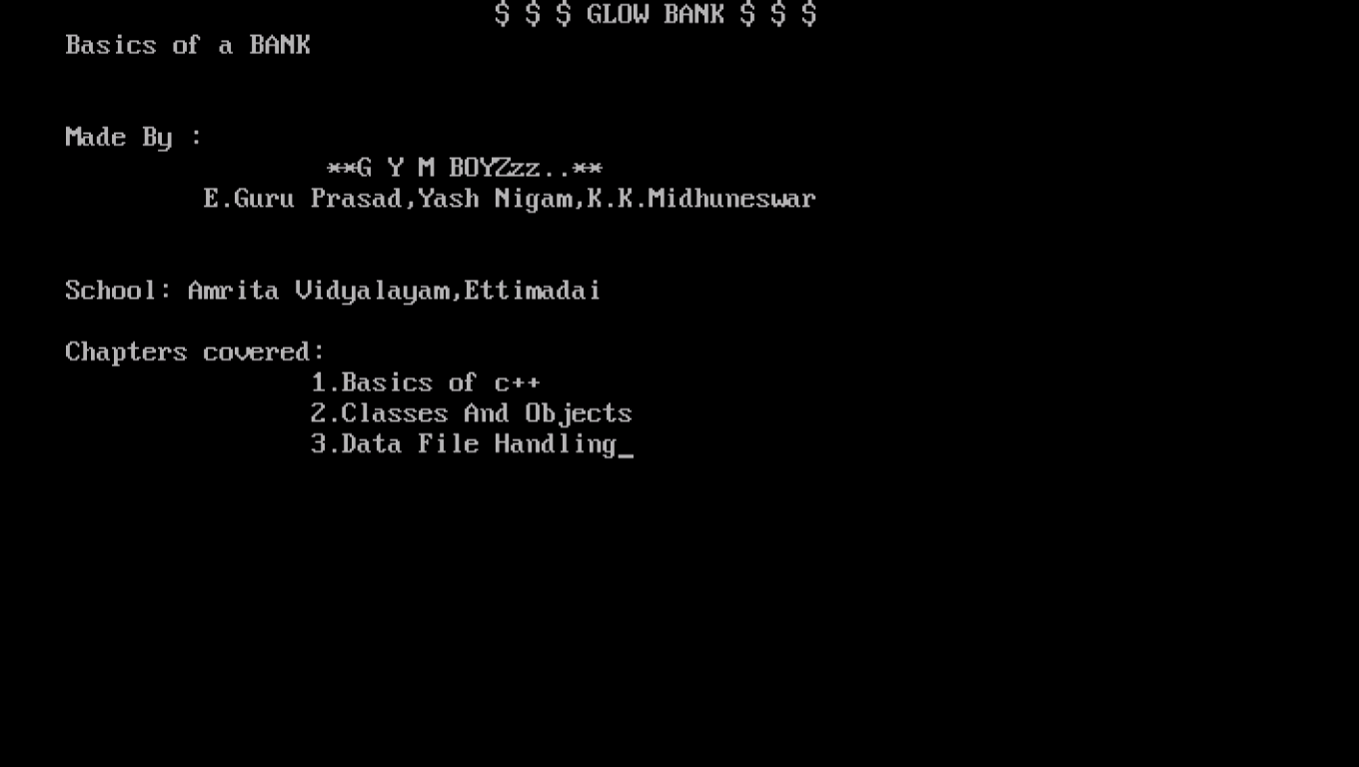

**Main menu of the BANK**

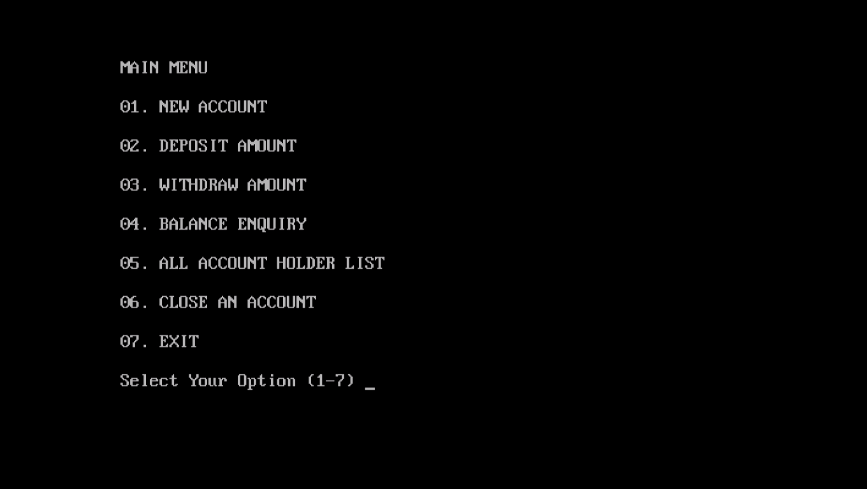

**Account Creation**

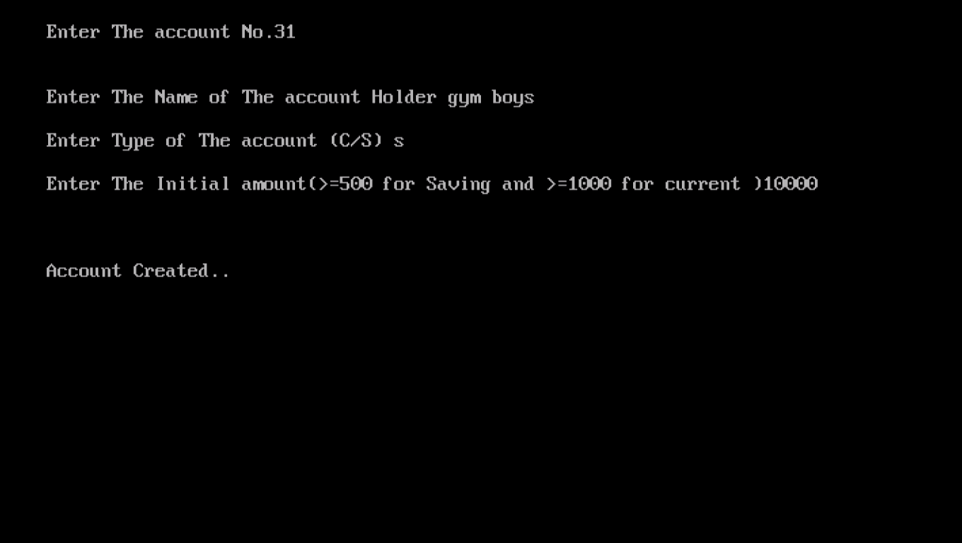

**Deposit Amount**

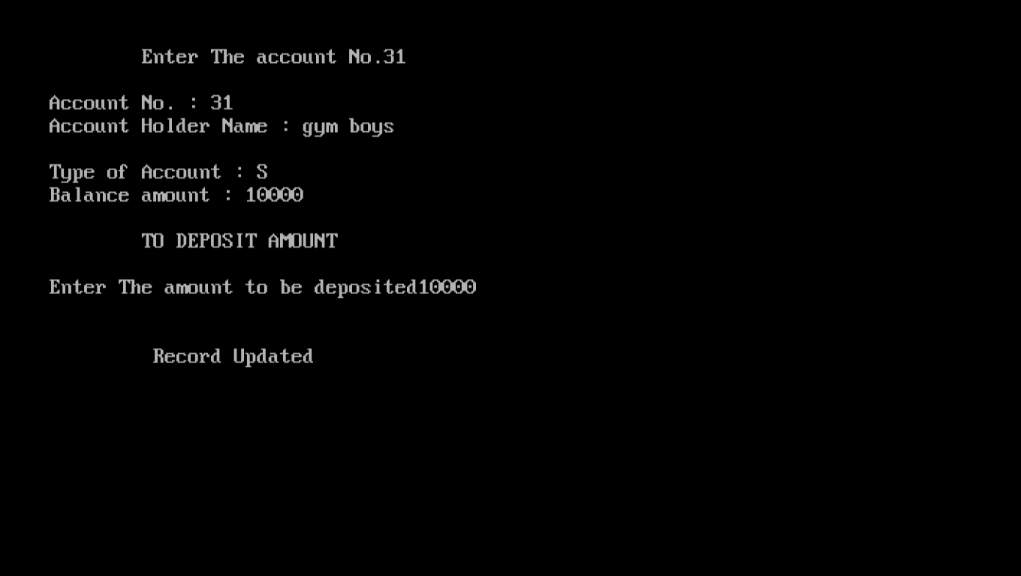

**Withdraw Amount**

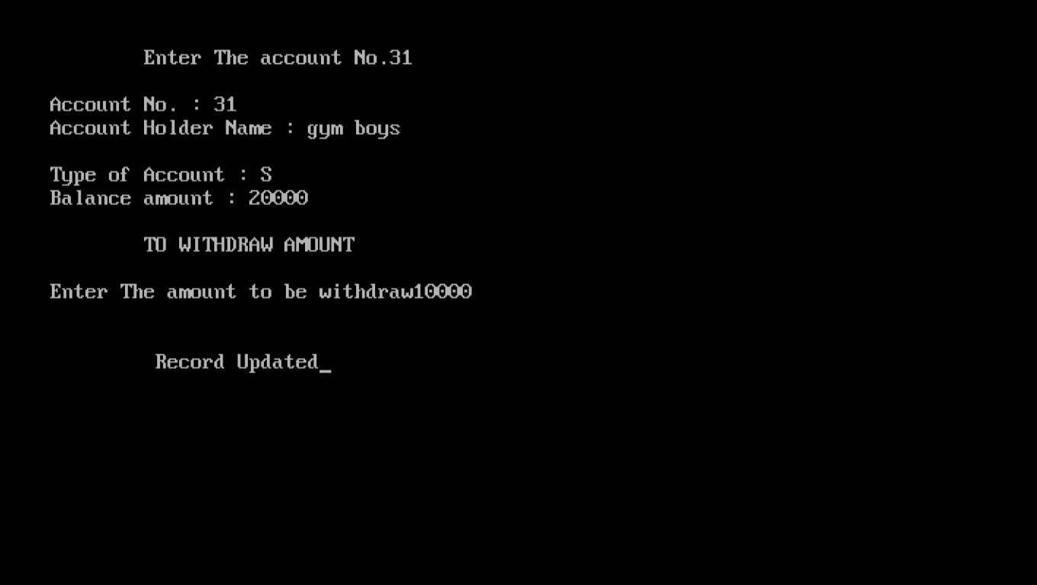

**Balance Enquiry**

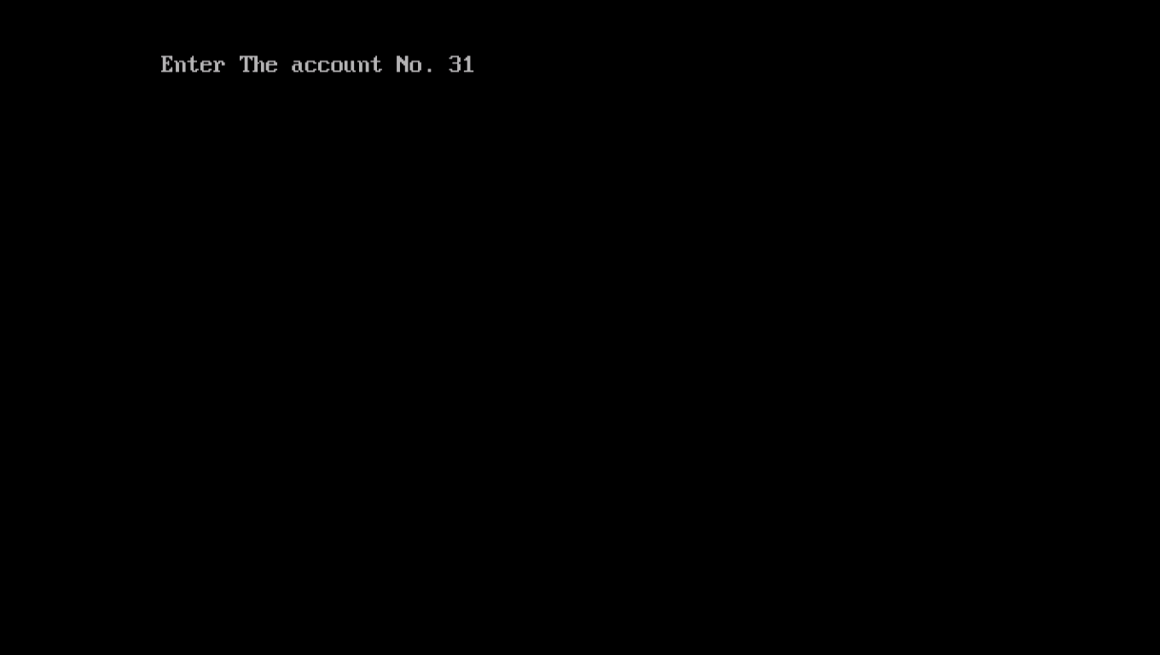

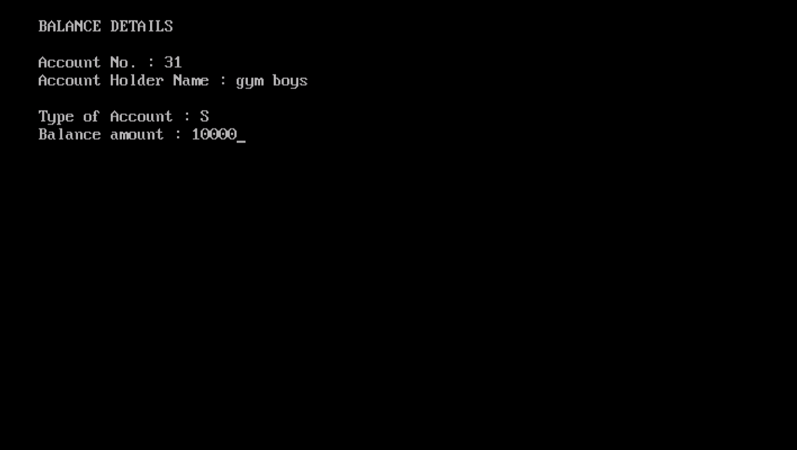

**Account Holder List**

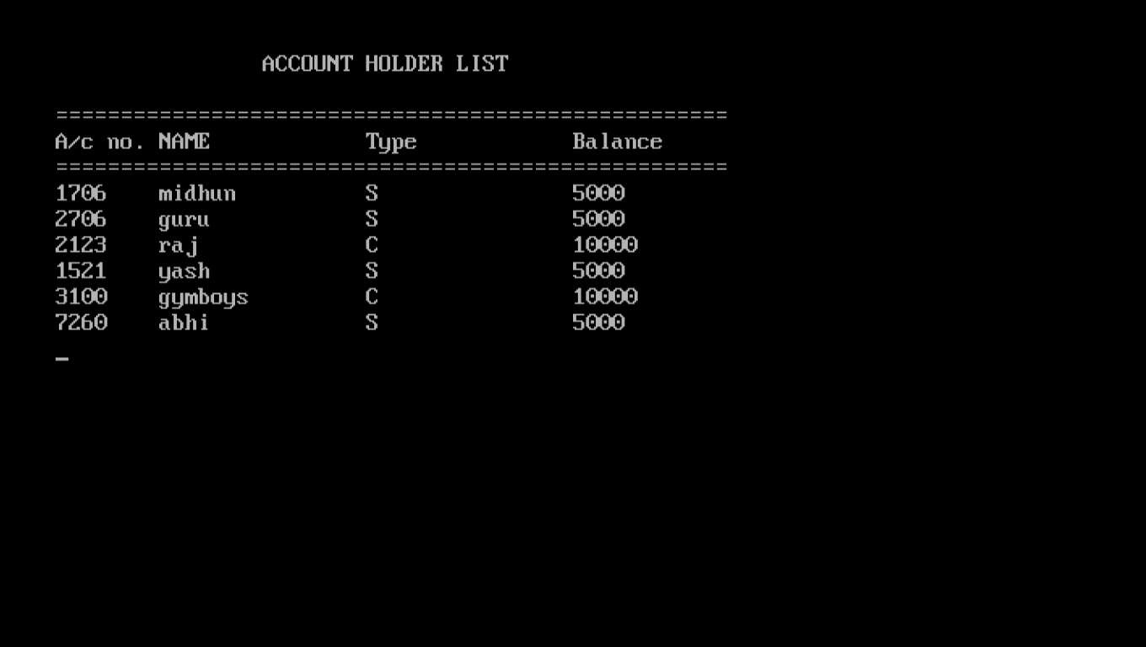

**Delete An Account**

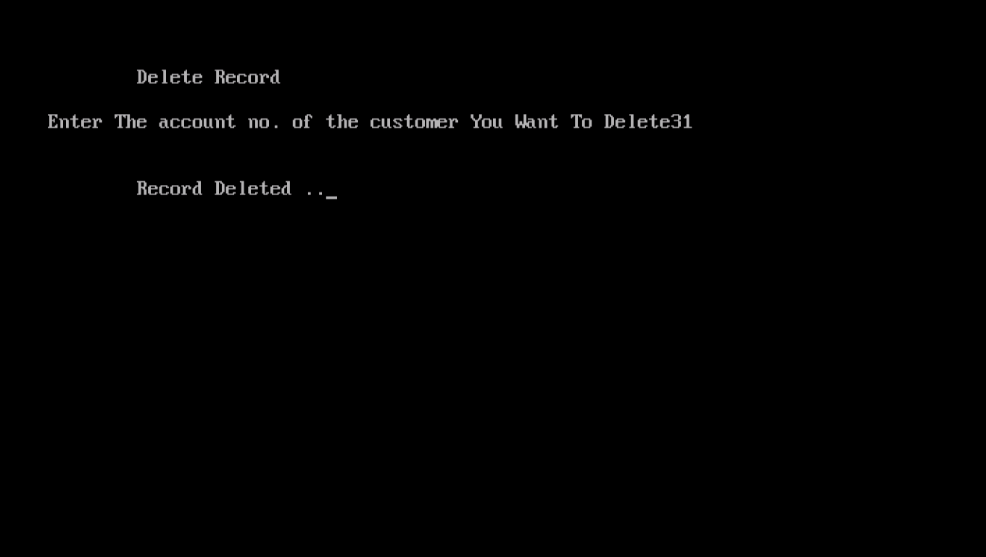

**Bibliography**

[www.projects.icbse.com](http://www.projects.icbse.com)

**Sumita Arora’s “Computer science with c++”**

**Ulla Kirch-Peter Prinz’s “A Complete Guide to Programming in C++**

**Learn C++ Complete Programming by** [www.tutorialspoints.com](http://www.tutorialspoints.com)